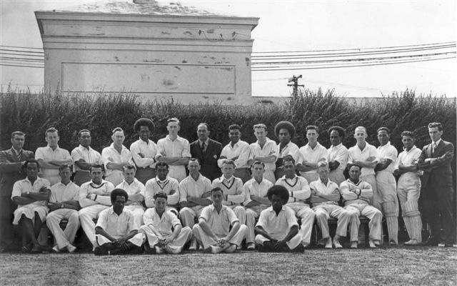 **Canterbury versus Fiji 5 March 1948 Lancaster Park**

Canterbury 421/9dec & 209/8dec. Fiji 276 & 318. Canterbury won by 36 runs